A Clinical Decision-making Framework against Over-testing based on Modeling Implicit Evaluation Criteria
Yang Yangª, Hongxing Huoª, Jia Suª, Jingchi Jiangª, Jing Xieª, Xuemei Sun^{b}, Xitong Guo^{c}, Shengping Liu^{d}, Yehan Wang^{d}, Yi Guan^{a,*}
ªSchool of Computer Science and Technology, Harbin Institute of Technology, Harbin 150001, China
^{b}Hospital of Harbin Institute of Technology, Harbin 150003, China
^{c}School of Management, Harbin Institute of Technology, Harbin 150001, China
^{d}Unisound AI Technology Co., Ltd, Beijing 100083, China
*Correspondence address: Yi Guan, School of Computer Science and Technology, Harbin Institute of Technology, Integrated Building Room 803, Harbin Institute of Technology, Harbin 150001, China. Tel.: +86-152-4510-7281; guanyi@hit.edu.cn.
Abstract
Background and objective: Considering the great harm caused by over-testing to the resources of medical institutions as well as patients’ property and health, a clinical decision-making framework against over-testing is deadly needed. Here we propose a general solution to automatically determine the appropriateness of diagnostic tests recommended by physicians for various diseases.
Methods: For evaluating the appropriateness of diagnostic tests in a unified way, we summarized the implicit evaluation criteria by analyzing medical reasoning process for over-testing. Further, four evaluation strategies were built as features of the clinical decision-making framework against over-testing based on modeling implicit evaluation criteria(CDFO-MIEC). Before we generated it with four corresponding processes implemented by statistical methods such as Multi-label K-nearest neighbor (ML-KNN), entities such as diseases, symptoms, tests and test results in medical records as computing elements were obtained after named entity recognition (NER) and entity alignment. Meanwhile, interpretability was provided by decision conditions in classification and regression tree (CART) to support the clinical decisions and increase the acceptance of the results from CDFO-MIEC.
Results: We experimentally found that CDFO-MIEC yielded an Macro_F₁ of 0.9167, verifying the feasibility of determining the existence of over-testing using automatic approaches. The results indicate that four evaluation strategies in CDFO-MIEC are imperative and the correlation between complaint symptoms and diagnostic tests plays a decisive role.
Conclusions: The proposed framework is the first clinical decision framework with unified evaluation criteria against over-testing, and it is creatively modeled by automatic methods to carry out objectively. Further, its good performance highlights the feasibility and blazes a new trail against over-testing.
Keywords: over-testing, interpretability, clinical decision-making, multi-label classification

1 Introduction
Prior works indicate that the amount of unnecessary medical care is increasing, especially over the last two decades. In 2010, the Institute of Medicine stated that unnecessary services in medical care of the United States (US) made a great contribution to excessive expenditure each year accounting for approximately 28 percent. The increase in cases of over-testing has attracted wide concern in the world. With such a tense relationship between doctors and patients today, physicians deliberately allow patients to undergo a large number of unnecessary tests that are not required for disease diagnosis but for avoid risk liability due to insufficient evidence in any future disputes. However, this behavior always produces a cause for medical dispute called over-testing. For physicians, the reasons for over-testing can be concluded as fear of malpractice, lack of knowledge or confidence, profit or pressure from hospitals, inadequate educational feedback and information asymmetry from patients. Over-testing wastes limited medical resources, it also damages patients’ property by causing additional costs, as well as harming their physical well-being, and can even cause early loss of life. It may cause the “downstream effect” of over-diagnosis and over-treatment. Although the initial test causes no risks to health, poor results from this initial test can lead to subsequent invasive tests and side effects from treatment, such as the prostate-specific antigen test for early detection of prostate cancer. An urgent social problem that needs to be solved is how to guarantee the best utilization rate of hospital resources and protect the interests of patients in the medical field. Not too much or too little medical care may be best provided by an “independent doctor who is not beholden to ‘the system’, the hospital, the accountable care organization, or the government”. Patients with insufficient reserves of information or knowledge are hardly in a position to judge the appropriateness of the advice given or scheme proposed by their doctors, so it is important to develop an automatic clinical decision-making mechanism for diagnostic tests with medical knowledge as an ‘independent doctor’.
A series of methods against over-testing have been designed which can be mainly divided into two types: 1) subjective criteria based. Such methods typically make decisions manually by experienced physicians to determine whether a test in ordering is unnecessary. A recent survey of subjectively assessing over-testing by physicians in Japan suggested that 46% of participants believe that at least 30% of overall tests were unnecessary. This revealed a similar magnitude of over-testing in Japan compared to that in the US survey. However, defining over-testing is challenging. There is no consensus on a detailed definition of over-testing, and the criteria for over-testing have not reached an agreement. In its broadest sense, over-testing is the subjecting of patients to diagnostic tests that do more harm than would otherwise be done. However, benefits or harms of this definition are rarely measured due to the delivery of diagnostic tests. As a result, for the same instance, the judgement of over-testing by different physicians is likely to be inconsistent. 2) Objective criteria based. This type of methods have primarily focused on the use of clinical practice guidelines (CPG), which is a rule-based method indeed. Evaluation indicators extracted from CPG are conducted for each test of a specific disease, which are hardly enumerated and too tedious and time-consuming to be operated by computers. For example, in , statements of guideline for incidental pulmonary nodules on abdominal CT are characterized as rules including the size of the largest nodule, patient age, history of smoking, and history of a malignancy treated within the past five years to determine whether followup chest CT should be recommended, and the recommended follow-up interval. However rules will vary with different tests or different diseases. Therefore, poor universality affects utility of such methods.
In recent years, the “algorithmic” view of medical processes has become an effective method to analyze electronic medical records (EMRs) and extract medical knowledge to provide decision-making support for the medical industry. As the electronic medical record system is widely implemented in hospitals around the world, the medical knowledge in the EMRs reflecting the authenticity, timeliness and objectivity of medical behavior is a valuable resource in the medical field. In this study, we propose a decision-making framework against over-testing by modeling the implicit evaluation criteria extracted from the empirical information in the clinical text of Chinese Electronic Medical Records (CEMRs) based on the multi-label classification and classification method, to assist clinicians in making wise decisions against over-testing in a doctor's recommended tests. There are four innovations in our research:
- To the best of our knowledge, this is the first study to assess the appropriateness of diagnostic tests to prevent over-testing by a statistic-based method automatically, especially in clinical text of CEMRs.
- We provide implicit evaluation criteria for over-testing, which can be seen as one-size-fits-all evaluation criteria to subjectively determine the appropriateness of diagnostic tests. In this way, benefits or harms of the delivery of diagnostic tests can be measured uniformly.
- Four evaluation strategies are built to model the implicit evaluation criteria by a statistic-based method. As shown in our experimental results, each evaluation strategy is indispensable in decision-making mechanism against over-testing. Compared with the previous CPG-based methods to over-testing, our approach is more versatile.
- Interpretability influences the perception of trustworthiness, effectiveness, and persuasiveness of a decision-making mechanism. Consequently, we provide a way to explain for each decision made by CDFO-MIEC through the decision conditions of a classification and regression tree (CART) when a diagnostic test is regarded as inappropriate for the current patient. For example, the evidences for this decision is supported by two decision conditions which are 2 out of 4 evaluation strategies with fairly low ranking including correlation with symptoms with ranking 151st of 230, and the usage rate under the condition of primary disease and differential disease with ranking 215th out of 230.

2 Related work
In order to confirm or rule out the presence of a disease or symptom, diagnostic tests are essential in assisting a doctor reach a comprehensive understanding of the patient's physical condition. Appropriate tests play a decisive role in a doctor's diagnosis. A means to provide an effective decision-making method to assist clinicians by recommending appropriate diagnostic tests remains a critical goal in efforts to protect the life and property of patients. We investigated the current state of research on over-testing, and was inspired by the work of statistic method based clinical decision-making support system in disease diagnosis and multi-label classification methods to construct an effectively automatic method against over-testing.
2.1 Clinical decision-making support systems in disease diagnosis
Clinicians perform complex cognitive processes to make optimal clinical decisions such as clinical diagnostic inferencing, medicine and diagnostic test recommending. To assist clinicians in taking the right decision in a very short time, clinical decision-making support system was proposed to automate these medical processes. Nowadays, there have been made great achievements in the field of medical auxiliary diagnosis. Decision-making methods in medical diagnosis can also be reference to medicine and diagnostic test recommendation. There are mainly two types of such methods: 1) rule-based methods. For each input EMRs, they carry out reasoning through bodies of knowledge which denoted by hand-crafted rules to search the disease which fits these diagnosis rules best and then make a decision. CPGs as systematically developed statements are still extensive text, which can be difficult to read and support physicians. Therefore, these barriers stimulated the development of CPG based clinical decision support systems which can computerize statement as rules. However, rule-based methods are typically hard to enumerate and time-consuming. 2) statistic-based methods. They work with data by analyzing and attempt to make the computer better understand EMRs, and then make a diagnosis accordingly. Classification is one of the most widely researched topic in medical diagnosis. Adil et al. proposed a decision support system for diagnosis of traumatic brain injury, which used a disease state index machine-learning algorithm. In, a medical knowledge network based on information extraction in clinical text of CEMRs was created and its joint probability distribution captured by a Markov network was used to make a diagnosis. Similarity with this paper is that we adopted same data form in clinical text of CEMRs. They extract medical knowledge by NER without entity alignment although the benefits of entity alignment are obvious. What’s more, this method is used for single-label classification rather than multi-label classification. Lipton et al. trained Long Short-Term Memory Networks (LSTMs) to classify 128 diseases based on time series of clinical measurement data. this method is proposed to tackle time series of data comprised of clinical measurements instead of textual data in our manuscript. An attentional convolutional neural network was proposed to predict disease codes from clinical text. Although rule-based methods are time-consuming and tedious when setting up as well as low efficiency in viable utilization, they have historically dominated over statistic-based methods. This is mainly because medical data has always been more difficult to acquire, due to legal and ethical reasons. Therefore, current researches on clinical decision-making support system against over-testing are still based on CPG.
2.2 Researches on over-testing
Precision medicine has promoted concerns about over-testing, which can be divided into non-methodological and methodological researches. In academic field, the majority of work concerning over-testing focuses on non-methodological techniques, including providing an overview of over-testing consequences, or subjectively estimating over-testing by experienced physicians.
Current methodological researches to explore the incidence of over-testing are mainly based on CPG. There have been considerable efforts to operate and computerize CPG. The global initiative for chronic obstructive lung disease guideline was applied to detect inappropriate testing, in which 11 out of 47 diagnostic tests were overused more than 50% of the time such as Echocardiography, urinary cultures, upper endoscopy and colonoscopy. And “Meta-analysis of Observational Studies in Epidemiology” and “Preferred Reporting Items for Systematic Reviews and Meta-Analyses” guidelines were used as measures of appropriateness to estimate laboratory testing. However, guidelines used as markers of healthcare appropriateness are time-consuming and heterogeneous. As yet there is little research into determining the appropriateness of diagnostic tests with a uniform statistic method to avoid over-testing. The latest research proposed new distance and similarity measures based on probabilistic interval-valued intuitionistic hesitant fuzzy set to reduce excessive re-examinations. This method aimed to reduce repetition of tests that have already been performed in other hospitals, however, the problem of how to avoid administering excessive tests during the initial diagnosis was not mentioned.
2.3 Multi-label classification methods
In the medical field, clinical decisions made for a patient with clinical manifestations, no matter in the task of making the diagnosis, recommending medicines or diagnostic tests, are usually multiple at a time. Multi-label classification methods have adapted to classify illnesses of chronically ill patients for decision support. In contrast to single-label classification, candidate labels in a multi-label classification are correlated instead of mutually exclusive. Problem transformation and algorithm modification are usually used to solve the problem of multi-label classification.
Problem transformation. This refers to the transformation of a multi-label problem into multiple single-label problems through the operation of decomposition or transformation of the sample set, and then processing these problems by various classifiers such as Support Vector Machine (SVM), naïve Bayes and the like. There are two typical problem transformation methods. One is a label-independent method such as binary relevance (BR) in which the problem is transformed by considering the prediction of each label as an independent single-label problem. Obviously, a label-independent method does not take into account the internal association among labels, which is the key to distinguishing single-label classification from multi-label classification. The other method is a label-dependent method such as label powerset (LP) in which the problem is transformed by creating a new label for different combinations of multiple labels. However, it cannot predict new label combinations despite high algorithm complexity, and it has the problem of sparse training data with the new created labels. Classifier chain (CC) concatenates the independent classifiers on the basis of BR, so that the current classifier takes the output of all previous classifiers as additional input information and passes label information in a chain to express the association among labels.
Algorithm adaption. This is a method used to adapt to the characteristic multi-label classification problem by modifying a particular algorithm rather than changing the sample set to fit the single-label algorithm. Typical algorithms are introduced as follows:
- Multi-label K-nearest neighbor (ML-KNN). ML-KNN is an algorithm adaption method of the K-nearest neighbor (KNN) method. ML-KNN finds k nearest instances to it by the traditional KNN method, and then uses prior and posterior probabilities of each label within the K-nearest neighbors to determine the label set of the test instance.
- Back-propagation multi-label learning (BPMLL). This is the adaption algorithm of neural networks for multi-label classification, which is modified by a multi-layer feedforward neural network and take new error formula into consideration.
- Multiclass multi-label perceptrons learner (MMP). MMP is an extension of the BR algorithm based on the perceptron algorithm specifically designed for optimizing multi-label ranking.

3. Material and method
Our purpose is to strike a balance between minimizing the usage rate of unnecessary diagnostic tests to reduce the frequency of false positive results and maximizing the usage rate of appropriate diagnostic tests to avoid omission of true positive results. Given the patients’ clinical manifestations in CEMRs, we aim to automatically determine whether a diagnostic test prescribed by a physician is appropriate by a uniform framework. Necessary definitions, architecture and clinical data of clinical decision-making framework based on modeling implicit evaluation criteria against over-testing(CDFO-MIEC) are described in this section.

3.1 Definition
A precise definition and specific evaluation criteria of over-testing are urgently needed. The tests in this paper refer to those diagnostic tests that a patient needs to pay for specially. Therefore, before over-testing is defined as Definition 4, the test, the diagnostic test and the test items are defined as Definitions 1, 2 and 3, respectively, to make distinctions.
Definition 1: A test is a measure taken to confirm or exclude the presence of a disease or symptom for a patient. Examples include ‘electrocardiograph’ (ECG), ‘blood routine’, ‘heart rate’ and ‘double lung percussion’.
Definition 2: A diagnostic test is a test which demands patient expenditure, such as test using a specific auxiliary device (ECG requires an electrocardiograph) or laboratory procedure (blood routine test requires a blood test procedure). In the test examples given in Definition 1, ‘ECG’ and ‘blood routine’ belong to the diagnostic test category, whereas ‘heart rate’ and ‘double lung percussion’ do not belong to the diagnostic test category.
Definition 3: Test items (test indicators) refer to the physiological indicators that can show patient's physical signs in the auxiliary test, which are commonly quantified by the measured value or the index value. For example, ‘leukocyte count’, ‘hemoglobin’ and ‘neutrophilic granulocyte percentage’ are test items in ‘blood routine’.
Definition 4: Over-testing is the application of a diagnostic test with little correlation or even irrelevance to disease diagnosis or treatment which a doctor recommends for a patient and results in the patients' excessive expenditure.
We analyze the clinical thinking process[] about which diagnostic tests a physician makes recommendations for a patient. Under the guidance of 3 physicians (One of them is the dean of the hospital and concurrently responsible for the quality control of medical records. The other two are chief physicians), we conclude the requirements for forming diagnostic test plan is to identify a potential connection between complaint symptoms and diseases, and to confirm or rule out the suspect diseases. The medical reasoning process for recommending diagnostic tests by physicians is shown as Figure 1.
The main function of the diagnostic test is to exclude or confirm suspect diseases. Therefore, in the process of judging the appropriateness of a diagnostic test, the exclusion function and confirmation function should be taken into account. By evaluating each diagnostic test in the way above, physicians ranked diagnostic tests and recommended the most appropriate diagnostic test for patients.
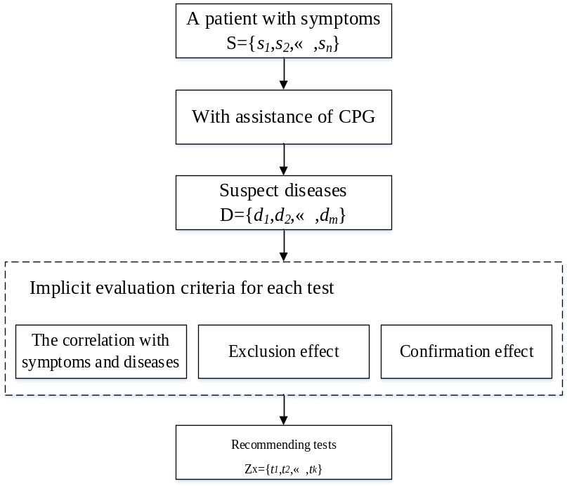
Fig 1. The medical reasoning process for recommending diagnostic tests by physician. m suspect diseases denoted by D={d₁,d₂,…,d_{m}}are carried out with the assistance of the CPG, a type of authoritative basic knowledge, when the patient provides his/her own physical information in the form of n complaint symptoms denoted by S={s₁,s₂,…,s_{n}}. Implicit evaluation criteria including three parts are taken into account for each test, and then appropriate tests Z_{x}={t₁,t₂,…,t_{k}} are recommended.

3.2 Architecture
Based on the above analysis and the definition of over-testing, we define the implicit evaluation criteria for avoiding unnecessary diagnostic tests after discussing with physicians. With the implicit evaluation criteria, it can be easy to determine whether the diagnostic test is over-testing by physicians subjectively. The implicit evaluation criteria include three factors to determine the appropriateness of a diagnostic test, which are 1) the correlation with symptoms and diseases: there is little or no relationship between the diagnostic test and the symptoms or related diagnosis (including the primary diagnostic disease and differential diagnostic disease); 2) exclusion function: diagnostic tests without abnormal results are not used to exclude a differential diagnostic disease; 3) confirmation function: expensive tests do not play a decisive role in the diagnosis of disease. In order to automatically determine the appropriateness of a diagnostic test, it is crucial to consider the implicit evaluation criteria thoroughly.
To model the correlation with symptoms and diseases, we carry out multi-label classification to measure correlation between complaint symptoms and diagnostic tests. As for correlation with diseases, two aspects which are the usage rate and the usage effect of diagnostic test t under the condition of related diagnosis should be considered, where the usage effect of diagnostic test can be represented by abnormal test result. Besides, because an appropriate diagnostic test with higher usage rate and lower usage effect is supposed to be used for excluding a disease, the usage rate and the usage effect of diagnostic test t under the condition of related diagnosis can be also used to model the exclusion function. According to the definition of confirmation function, the usage effect and price information of a diagnostic test can not be ignored. In conclusion, the implicit evaluation criteria can be modeled by four evaluation strategies which are the correlation between complaint symptoms and diagnostic tests, the usage rate of diagnostic test t under the condition of related diagnosis, the usage effect of diagnostic test t under the condition of related diagnosis and the price index. The corresponding basic framework to determine the appropriateness of a diagnostic test is shown in Figure 2.
After defining the implicit evaluation criteria and over-testing by communicating with medical experts, four evaluation strategies are presented to model the implicit evaluation criteria as features of each diagnostic test in CDFO-MIEC. As shown in Figure 2, the final purpose of CDFO-MIEC is to make a decision to determine whether a diagnostic test is appropriate, which can be regarded as a binary classification for each diagnostic test. Meanwhile, CART can provide interpretability depending on the decision conditions besides it shows competitive performance comparing with other binary classification methods. Considering the effectiveness and persuasiveness simultaneously, we choose the decision tree learner CART for the binary classification. The CART algorithm is used to construct a binary classification tree by selecting a feature with minimum Gini Gain as the cut-off point. To ensure the quality of analytical data, we extracted the informative sub-modules from the complicated clinical text of CEMRs. For practical needs, named entity recognition (NER) and entity alignment are adopted to obtain the computing elements of four evaluation strategies.
The whole set of CDFO-MIEC for reducing over-testing is a supervised learning method. Let X denote the domain of instances which are all patients. For instance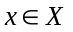, let Y denote all candidate diagnostic tests after entity alignment, Y_{x} (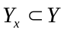) denote a collection of candidate diagnostic tests of instance x, S denote all complaint symptoms after NER and removing negative entities, and S_{x} (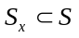) denote a collection of total complaint symptoms of instance x. We characterize patient x by complaint symptoms 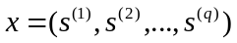, 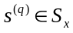, then x can be represented as a |S| dimensional multi-hot vector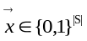. There is 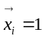 if the corresponding complaint symptom at i^{th} dimension of is an element of S_{x}. And a |Y| dimensional multi-hot vector 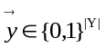 represents multiple diagnostic tests applied for a patient. There is 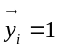 if the corresponding diagnostic test at i^{th} dimension of is an element of Y_{i}.
Suppose that diagnostic tests recommended by a physician based on training data are appropriate, inappropriate data were constructed in a ratio of 1:1 by randomly adding tests which had not appeared in a physician’s ordering. All instances can be divided into two disjoint parts which is a training set X_{t} and a test set X_{e}, represented as X={X_{t}, X_{e}}. For each diagnostic test t_{i} in Y_{x}, let o be the value of the output variable. And then a training set is represented as T_{CART}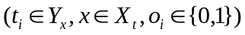 where o_{i}=0 means diagnostic test t_{i} is inappropriate for current patient, o_{i}=1 means diagnostic test t_{i} is appropriate. For each patient containing the symptoms in testing data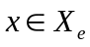, let R be a collection of the related diagnosis of a particular patient x which consists of primary diagnosis and differential diagnosis. For each diagnostic test t in Y_{x}, t can be denoted by 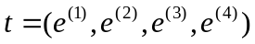, 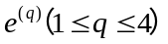denotes the q^{th} feature of t, and each feature is represented by an evaluation strategy described as follows.
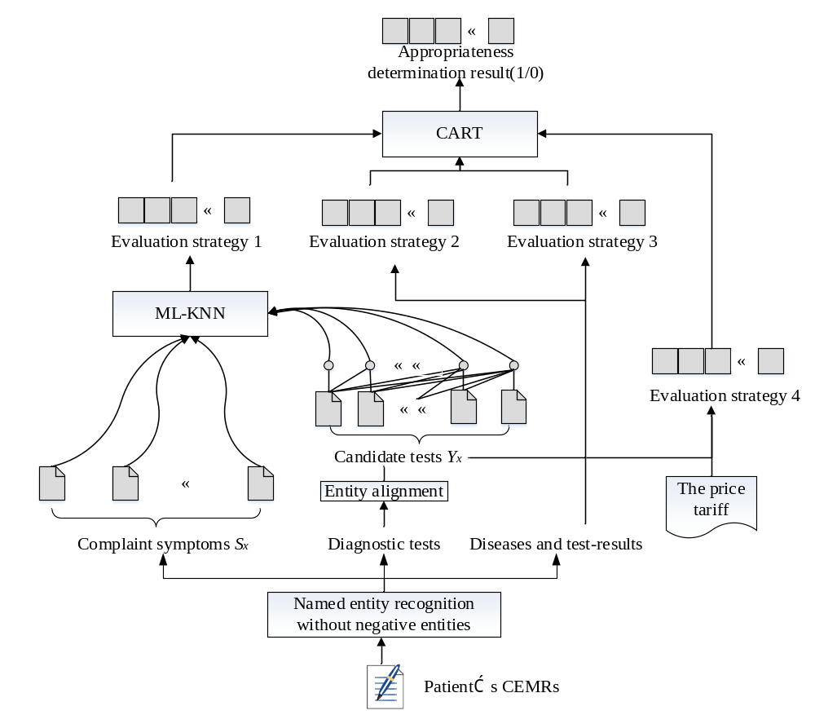
Fig. 2 Basic framework of CDFO-MIEC. CEMRs are processed using NER and filtered afterwards to only include positive named entities (complaint symptoms S, diagnostic tests, diseases and test results). Negative entities are those modified by negative words including ‘未’, ‘无’, ‘否’, ‘不’. Then entity alignment is used for all entities of diagnostic test to produce candidate diagnostic tests Y. For each patient, a visit event can be represented by a pair of multi-hot vectors in the form of (,) as input of ML-KNN to produce results of Evaluation strategy 1 in Eq.2. In meantime, Evaluation strategy 2, 3, 4 are generated by accepting diagnostic tests, diseases, test results and price in Eq.4, Eq.6, Eq.7. Finally, four evaluation strategies are input as features into CART to make decisions for over-testing.

Evaluation strategy 1: It is the correlation between complaint symptoms and diagnostic tests. In our application, multiple diagnostic tests will be recommended for the same group of symptoms at a time. Consequently, exploring the correlation between diagnostic tests and complaint symptoms can be considered as a multi-label classification problem. ML-KNN is selected to simulate the process of making a clinical decision by physicians based on patient similarity that physicians always relate a patient to the similar patients they have seen. For ML-KNN, training set can be represented as T_{Es1} 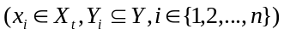. Let 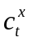 denotes the number of times label t appears in k nearest instances of instance x (1≤c_{t}≤k). The label set Z(x) of patient x can be predicted by maximum a posteriori principle, which tend to make t∈Z(x) if the hypothesis that instance x belongs to the label t has a greater posterior probability than the opposite hypothesis:
(1)
in which h_{t} represents the event that instance x belongs to the label t, and ¬h_{t} represents the event that instance x does not belong to the label t. According to the Bayesian rule, formula 2 can be rewritten by the prior probabilities P(h_{t}) and the posterior probabilities P(c_{t}^{x}|h_{t}) as shown in formula 2:
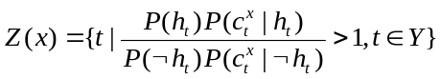 | (2)
Evaluation strategy 2: It is the usage rate of diagnostic test t under the condition of related diagnosis is denoted by UR(t). The purpose of a diagnostic test is either to confirm the existence of a disease or to exclude other differential diagnoses. A diagnostic test with higher usage rate in the past experience of a disease diagnosis can be a factor in determining the appropriateness of a diagnostic test. UR(t) can reflect the correlation between a diagnostic test and its related disease, exclusion function and confirmation function. Let C_{d} be the event that instance x has a condition of disease d (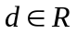), U_{t} be the event that diagnostic test t () is applied for instance x:
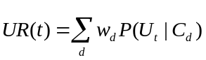 | (3)
where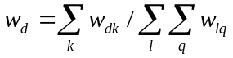 (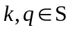,)is the weight to represent correlation between instance x and disease d, and 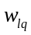 is the representation of correlation between disease l and symptom q measured by Markov logic network. The closer the correlation, the greater the weight 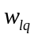 is. 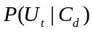 represents the usage rate of diagnostic test t under the condition of disease d. According to conditional probability, it can be formulated as Equation 4:
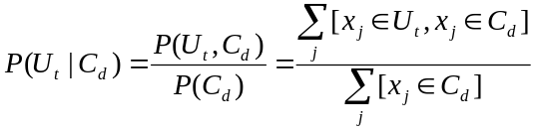,  | (4)
Evaluation strategy 3: It is the usage effect of diagnostic test t under the condition of related diagnosis denoted by UE(t). A test result is the manifestation of the patient's physical signs, which provides powerful evidence in support of the diagnosis to exclude or confirm a disease. UE(t) highlights whether the diagnostic test is effective in the process of disease diagnosis based on the frequency of abnormal test results observed in patients and the higher the frequency, the better the usage effect is. In general, if a diagnostic test with high usage rate and low usage effect in the past experience of a disease diagnosis, this diagnostic test is used for exclusion function. Let A_{t} be the event that diagnostic test t () produces an abnormal test result:
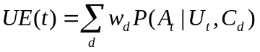 | (5)
because of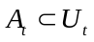, which means that a diagnostic test with an abnormal result must have been used for patient x, there is the equation A_{t} ∩ U_{t} = A_{t}, then P(A_{t}, U_{t}) = P(A_{t}). According to conditional probability, P(A_{t}, U_{t}, C_{t}) = P(A_{t}, U_{t})P(C_{t}|A_{t}, U_{t}) = P(A_{t})P(C_{t}|A_{t}) = P(A_{t}, C_{t}). Therefore, 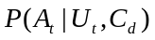 can be formulated as Equation 6:
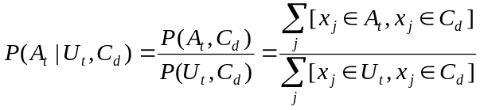, | (6)
Evaluation strategy 4: It is the price index denoted by I(t). The more expensive the diagnostic test, the higher the price index is. The most direct loss to patients caused by over-testing is the economic loss, and the economic benefit is also one of the driving forces of over-testing for doctors. In view of Feldman’s research, providing price data for physicians can result in a modest decrease in test ordering which may be a key factor against over-testing. Thus, the impact of a diagnostic test price on appropriate test recommendation has to be taken into account. In general, for confirmation function, a diagnostic test with high price index should have high UE(t). The price index calculated by the z-score is the market price represented as the relative price of each diagnostic test t:
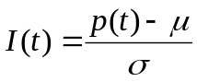 | (7)
where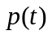represents the practical price of diagnostic test t,  represents the average price of all diagnostic tests, and represents the standard deviation of the diagnostic test price.
Therefore, implicit evaluation criteria can be modeled by four evaluation strategies. The four evaluation strategies are interdependent and work together to determine the appropriateness of the diagnostic test.

3.3 Clinical data feed
EMRs are objective records of medical activities suffering by a patient. They are an embodiment of patient health information and a reflection of a doctor’s experience and knowledge. EMRs are usually stored in clinical text, a nonstructural data form. Thus, many efforts have been devoted to data mining and knowledge discovering for clinical text. We believe that the analysis of EMRs in the same medical department can reveal the knowledge existing in medical activities. Because medical data are often difficult to obtain, there is no publicly available CEMRs dataset. Besides, we have already laid a solid foundation on the analyzing and processing of CEMRs. For this study, we adopted 2,860 texts of CEMRs from the respiratory medical department of a grade III, class A hospital in China as the data source. The four categories of primary entities in the CEMRs that are bound up with the processing of disease diagnosis are the complaint symptom, test, test result and disease.
With the aim of determining the appropriateness of diagnostic tests for clinical text, the corresponding sub-modules in CEMRs containing a rich store of information concerning diagnosis and diagnostic tests are extracted and merged. Each of the texts contains nine parts in free-form text which are physical examinations, history of present illness, past medical history, admission situation, complaint symptom, conversation content, treatment process, medical advice at discharge, and auxiliary diagnostic test. The structure of merged clinical text is shown in Figure 3.
Extracting effective information from clinical text is the key to determining the appropriateness of diagnostic tests. In this study, NER and entity alignment technologies were applied to extract elements which could be used in computing evaluation strategy 1–4.
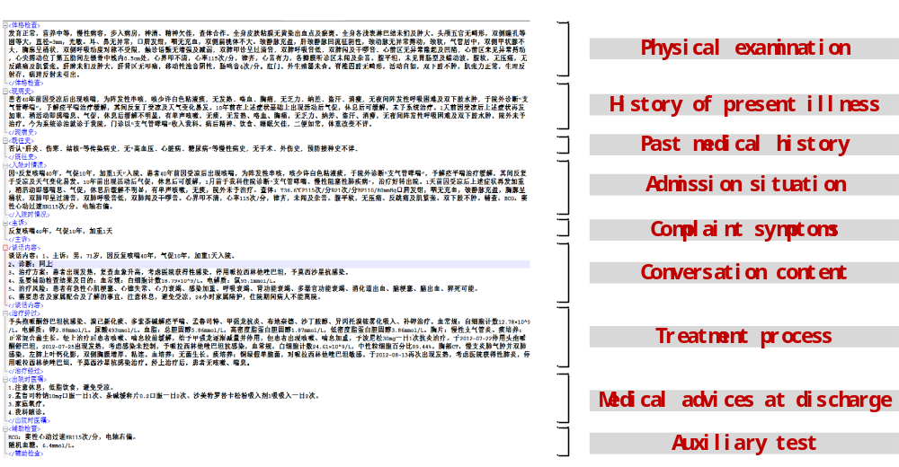
Figure 3. A sample from the clinical text of CEMRs

3.3.1 Named entity recognition
NER is a fundamental and indispensable information extraction task to extract medical entities such as disease, test and symptom from clinical text. Referencing the medical concept annotation guidelines and the assertion annotation guidelines provided by Informatics for Integrating Biology and the Bedside 2010, five types of named entities were identified: “test”, “complaintsymptom”, “testresult” “disease” and “treatment”. The related annotation resources are available at http://github.com/WILAB-HIT/Resources. A total of 2,343 texts randomly selected from ten different departments (pediatrics, gynecology, internal medicine, surgery, emergency medicine, neonatology, ophthalmology, oncology, otolaryngology and Chinese medicine) were annotated by medical professionals as the training data for the NER model. In order to lay a solid foundation for CDFO-MIEC, the accuracy of NER must be guaranteed. We choose long short-term memory networks together with conditional random field (LSTM-CRF) which outperforms other traditional baseline methods in NER tasks. In addition, in order to improve the performance of the LSTM-CRF model, a word-based vector was combined with a character-based vector for the input layer in the network. We used the Lexical Analyzer for Chinese word segmentation tool from Tsinghua university. Furthermore, the pre-trained Chinese word vectors trained by Baidu Encyclopedia, Chinese Wikipedia, People's Daily and Sogou News were used as word-based vectors. With model parameters of word vector dimension 400, character vector dimension 256, lmini-batch 10, dropout rate 0.5, training samples 1,757 and evaluation samples 586, the performance of the NER model is shown in Table 1.
Table 1 NER performance of improved LSTM-CRF
LSTM-CRF | Precision | Recall | F₁
complaintsymptom | 0.9016 | 0.9339 | 0.9175
disease | 0.7622 | 0.8462 | 0.8020
test | 0.7226 | 0.9298 | 0.8132
testresult | 0.8223 | 0.8130 | 0.8177
treatment | 0.6879 | 0.7551 | 0.7199
The NER processing method in this study is available in the Github repository, https://github.com/yang1992samantha/CDFO-MIEC/tree/master/ner_v1.

3.3.2 Entity alignment
Names of a diagnostic test in the clinical text are usually informal. However, in fact, there are corresponding professional medical terms. For instance, ‘胸平片’ (chest X-ray), ‘胸片’ (chest film), ‘胸部正侧位’ (front and lateral chest radiographs) and ‘胸正侧位片’ (anteroposterior and lateral position films) all have the same meaning in the medical field which are referred to as ‘胸部正侧位片’ (lateral chest radiograph) in hospital medical terminology. The problem of an entity with various synonymous entities can be handled by entity alignment. Aiming at the requirement that diagnostic tests are used to calculate evaluation strategies 1–4, two characteristics of the diagnostic test should be satisfied.
- Uniqueness. That is, there should be only one name of test entities with the same meaning in the label set.
- Atomicity. That is, the diagnostic test as a class label can no longer be separated.
In order to satisfy the conditions above, we achieved entity alignment by combining the string metric computing method named Levenshtein distance with verification by a professional physician. Firstly, we separated test entities obtained from NER which did not meet the requirements of atomicity by rules matching. Rules were made by summarizing the features of data, such as entities including Chinese words like ‘及’ (as well as), ‘加’(plus), ‘和’(and), ‘+’, which indicated that the string with one of these words contains two or more test names used as class label. Secondly, we ensured that a split-adjusted string of diagnostic test in the clinical text remains in line with a medical term used in hospital through the Levenshtein edit distance method. Levenshtein edit distance measures similarity between two words by computing the number of character changes (insert, delete, and replace) required to turn one into another. We calculated the similarity between two strings using the Levenshtein distance as shown in Eq.8. If the Levenshtein ratio was greater than 0.7, the two strings were considered to be similar:
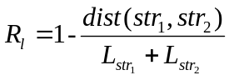 | (8)
Where L_{str1} and L_{str2} represent the lengths of string 1 and string 2 respectively. dist(str₁,str₂) calculates the minimum distance required to change from string 1 to string 2 by operations of inserting, deleting, or replacing, and each operation which is applied increases the distance by one. For example, string 1 is ‘大便常规’ (stool routine) and string 2 is ‘粪便常规’(stool routine), the Levenshtein distance between these two strings is 7/8 which means these two strings can be matched. Finally, in order to improve the precision of entity alignment, we invited two clinical physicians to verify and correct the results obtained from Levenshtein distance calculations.

4 Results
To evaluate the performance of CDFO-MIEC, we conducted experiments using 2,860 texts from the respiratory medical department. Since the 2,860 electronic medical records obtained at present are qualified medical records reviewed and approved by the medical records quality control department, the recommended diagnostic tests in CEMRs are all appropriate. Inappropriate data were constructed in a ratio of 1:1 by randomly adding tests which had not appeared in a physician’s recommendation. The dataset size of diagnostic test for 2,860 patients was 41,470, half of which was constructed from inappropriate diagnostic tests. For each diagnostic test of a clinical text among the 2,860 instances, four-dimensional features including correlation between complaint symptoms and diagnostic tests, UR(t), UE(t) and I(t) were input into a CART to determine to which class a diagnostic test in current clinical text should belong, appropriate or inappropriate. To effectively mitigate the negative effects of extreme values and outliers in continuous data, it is necessary to discretize the four evaluation strategies before they are used as the input data of CART. The discretization algorithm adopts the clustering algorithm (k-means).
After NER and entity alignment, we adopt 2171 kinds of complaint symptoms and 230 kinds of diagnostic tests as features and labels of ML-KNN to calculate Evaluation strategy 1. And evaluation strategy 2 and 3 are calculated by basic statistic-based methods. In this paper, the effectiveness of CART algorithms was evaluated by comparing with seven machine learning algorithms which were logistic regression (LR), KNN, naïve Bayes (NB), SVM Recurrent Neural Networks (RNN) and convolutional neural network (CNN).
Determining appropriateness correctly includes two cases: the correct judgement of appropriate diagnostic test and the correct judgement of inappropriate diagnostic test. We use Macro-average of Precision (Macro_P), Recall (Macro_R) and F₁-score (Macro_F₁) to evaluate the performance of our model. Precision P, Recall R and F₁-score F₁ are applied for evaluating the performance of each of two classes which are the class of appropriate diagnostic test and the class of inappropriate diagnostic test. P measures the proportion of positive samples in the classifed samples. R focuses on the coverage of diagnostic tests correctly determined appropriateness by CDFO-MIEC.
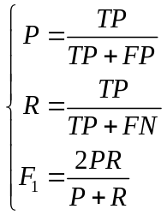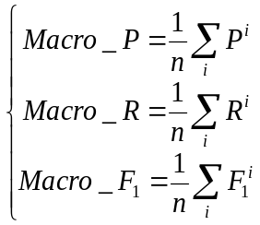 | (9)
where TP (True Positive) represents the number of positive samples that are predicted to be positive by the model, FP (False Positive) indicates the number of negative samples predicted to be positive, FN (False Negative) illustrates the number of positive samples predicted to be negative. For evaluating performance of classifying inappropriate diagnostic tests, positive samples refer to inappropriate diagnostic tests. For the other case, positive samples refer to appropriate diagnostic tests. In this study, n=2 and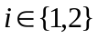.
The comparative experimental results of seven classification algorithms for measuring the performance of CDFO-MIEC are reported in Table 2. A 5-fold cross-validation method was performed, average and range of performance are represented. CART has achieved a competitive performance in terms of this data set.

Table 2. Performance of classification algorithms on decision-making for diagnostic test
Classifier | Macro_P | Macro_R | Macro_F₁
CART | 0.9173(0.9124,0.9224) | 0.9168(0.9119,0.9221) | 0.9167(0.9119,0.9221)
LR | 0.9157(0.9114,0.9211) | 0.9148(0.9106,0.9205) | 0.9148(0.9106,0.9205)
KNN | 0.9267(0.9211,0.9316) | 0.9266(0.9210,0.9316) | 0.9266(0.9210,0.9316)
NB | 0.9081(0.9032,0.9126) | 0.9063(0.9014,0.9112) | 0.9062(0.9013,0.9111)
SVM | 0.9173(0.9124,0.9224) | 0.9167(0.9119,0.9221) | 0.9167(0.9119,0.9221)
RNN | 0.9136(0.8987,0.9200) | 0.9113(0.8904,0.9193) | 0.9111(0.8987,0.9193)
CNN | 0.9171(0.9124,0.9224) | 0.9166(0.9119,0.9221) | 0.9165(0.9124,0.9221)

We use grid search to adjust the superparameters of each classification model: 1) for CART, candidate values of superparameters are set up as follows: maximum depth of decision tree can be 5, 10, 20, 30; maximum number of leaf nodes can be 500, 750, 1000; The minimum number of samples needed for internal node subdivision can be 100, 200, 300. The final superparameters are selected as 5, 500, 100 respectively. Due to the small feature dimension, the process of parameter adjustment has little influence on the performance. 2) For LR, candidate values of superparameters are set up as follows: regularize selection parameters are L₁ and L₂; the derivative of the regularization intensity C: 0.75, 1.0, 1.25; intercept/variance added to the decision model can be true or false. The final superparameters are selected as L₂, 0.75 and false. 3) For KNN, candidate weight functions are 'uniform' or 'distance', where 'uniform' means equal weight voting and 'distance' means to vote in inverse proportion to distance; candidate numbers of neighbors are 5, 10, 20, 50. After adjustment, the parameter are selected as 'uniform' and 50. 4) For NB and SVM, parameter adjustments have little effect on the result. parameter for NB is set up as smoothing parameter alpha=0.75, and parameters for SVM are set up as penalty parameter C=0.75, kernel type is ‘poly’, degree of the polynomial kernel function is 3. 5) For RNN and CNN, candidate values of superparameters are as follows: values of learning rate can be 0.005, 0.01, 0.02; values of L₂ regular parameter can be 0.00005, 0.0001, 0.0005; values of embedding dimension can be 32, 64, 128. The parameters selected after adjustment are 0.02, 0.0001 and 128, respectively.
With respect to the evaluation results, KNN performs best because there are many intersections or overlaps of the class domain in the data set of the experiment. For KNN, it mainly relies on the surrounding limited adjacent samples to determine the category, rather than relying on identifying the class domain. However, if the evidence for the decision is that the current patient is similar to several previous patients, it is not convincing to determine whether the diagnostic test is appropriate or not. CART can provide better interpretability for the decision by the decision conditions as described in section 5.3. What’s more, CART does not perform worse than the other methods with Macro_F₁ of 0.9167. Therefore, we finally choose CART as the binary classifier in CDFO-MIEC. NB shows the poorest performance because it supposes that features are independent of each other, while in fact the four evaluation strategies except Evaluation strategy 4 influence each other as described in section 5.1. For example, if a diagnostic test has a high correlation with the patient's current symptoms, then it is usually used more frequently under the condition of the patient's current related diseases. CNN and RNN do not perform as well as CART, possibly because our data scale is not particular large, and the input of these methods is four features processed by feature engineering manually, which can not display the advantages of extracting features automatically in these deep learning methods.

5 Discussion
In order to provide effective assistance for doctors in making intelligent decisions regarding recommended tests, four evaluation strategies are proposed to model the implicit evaluation criteria summarized from subjective medical decision-making process. To verify the feasibility of CDFO-MIEC, we discuss the effect of each of four evaluation strategies in section 5.1. Then we conducted experiments among multi-label classification methods to justify the competitive performance of ML-KNN in section 5.2. Finally, we exemplify interpretability of CDFO-MIEC.

5.1 Effect of evaluation strategy
To verify the necessity and accuracy of the four evaluation strategies summarized from the implicit evaluation criteria, we carried out the following experiments with different combinations of evaluation strategies. We exemplified the positive effect of each evaluation strategy on the Macro_P and Macro_R in determining the appropriateness of diagnostic tests. The results of unordered and random combination of the four evaluation strategies are shown in Figure 4. The classifier of each experiment used CART. Graphs (a), (b), (c), and (d) represent the impact on Macro_P and Macro_R of appropriate decisions of diagnostic tests in the absence of each of four evaluation strategies. For example, Graph (a) shows the role of Evaluation strategy 1 in CDFO-MIEC by comparing the performance before and after Evaluation strategy 1 was moved on both Macro_P and Macro_R. In each graph, f_{I} (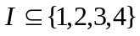) means that all Evaluation strategy i are used as features of CART at the same time, where.
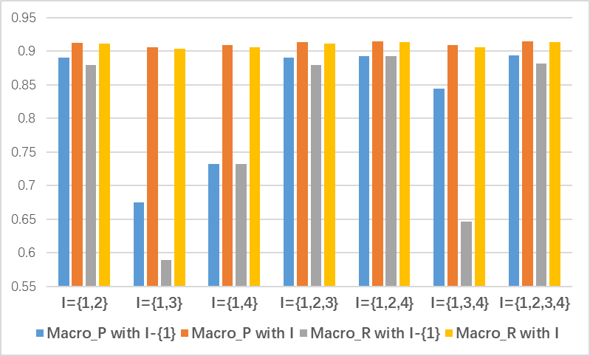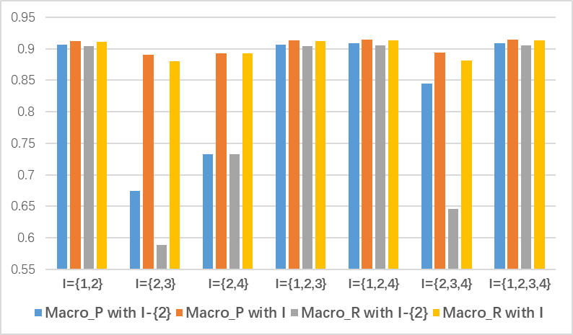
(a) effect of removing Evaluation strategy 1 (b) effect of removing Evaluation strategy 2
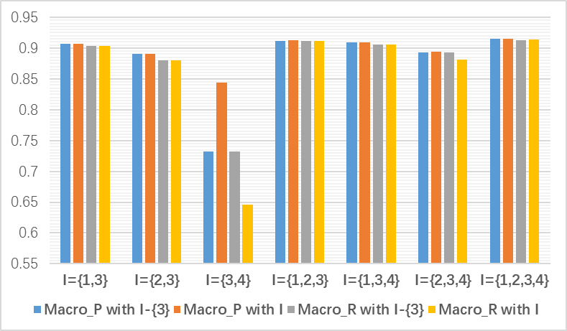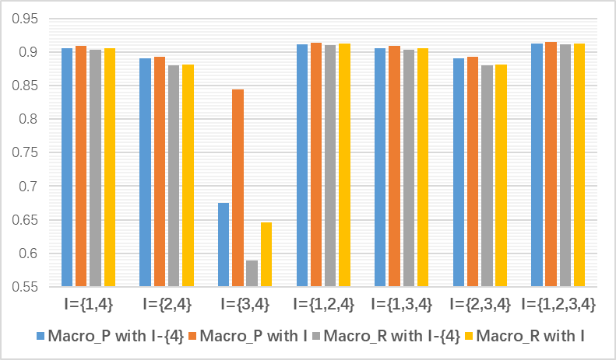
- effect of removing Evaluation strategy 3 (d) effect of removing Evaluation strategy 4
Figure 4. Effect of each evaluation strategy on determining the appropriateness of diagnostic tests
Our experimental results showed that the classification tree constructed from four evaluation strategies achieved the optimal performance with Macro_P of 0.9148 and Macro_R of 0.9133 for determining the appropriateness of diagnostic tests. Evaluation strategy 1, using ML-KNN to calculate the correlation between complaint symptoms and diagnostic tests, exerted a deleterious influence on determining the appropriateness of diagnostic tests. No matter how other evaluation strategies were combined, the Macro_P and Macro_R would not exceed 0.9 as long as there was no Evaluation strategy 1 according to graph (a), whereas classification performance could reach a Macro_P of 0.9064 and Macro_R of 0.9038 only with Evaluation strategy 1.
The most striking observation to emerge from the result comparison was the improvement effect of the addition of each evaluation strategy on determining the appropriateness of diagnostic test, which confirmed that the four evaluation strategies are indispensable. Although Evaluation strategy 3 caused a slight improvement to the final decision with respect to graph (c), the importance of determining the appropriateness of diagnostic tests cannot be overlooked. One reason for the insignificant improvement of Evaluation strategy 3 was the lack of information when identifying abnormal test results. Evaluation strategy 3 indicated the use effect of abnormal test results, whereas the abnormal test results in this experiment only considered text information recognized as the entity of ‘testresult’ by NER in clinical text. However, most abnormal test results were numerical or described as negative or positive which were not taken into account. Thus, this lack of information cannot properly reflect the use effect of each diagnostic test. As a result, the classification ability of this evaluation strategy is greatly affected, and should be further improved in follow-up research work. According to the definitions of Evaluation strategy 3 and Evaluation strategy 4, these two evaluation strategies are just the attributes of diagnostic tests which cannot reveal the appropriate use of these diagnostic tests. It can be seen from the implicit evaluation criteria that evaluation strategies 3 and 4 do not have the ability to independently determine the appropriateness of diagnostic tests. Experimental results using only Evaluation strategy 3 or only Evaluation strategy 4 also confirmed this assumption, giving quite poor performance on Macro_P and Macro_R.
We verified that each evaluation strategy was indispensable, although Evaluation strategy 3 had a slight effect due to insufficient information about test results. In fact, it should have played a decisive role in determining the appropriateness of diagnostic tests. In the future, we can focus on extracting the numeric or binary values of the test result data to enhance the influence of Evaluation strategy 3.

5.2 Performance evaluations for Evaluation strategy 1
In this experiment, the complaint symptoms are taken as features, diagnostic tests are taken as class labels and data are encoded in the multi-hot form. In order to ensure the robustness of the model, a 5-fold cross-validation method was performed on 2,860 texts from the respiratory medical department. The total number of symptoms as features of multi-label classification is 2171, and the total number of diagnostic tests as labels after entity alignment is 230.
Since each instance can belong to multiple labels at the same time, the performance evaluation of a multi-label classification algorithm cannot be measured by the recall and precision accuracy in the same way as a single-label classification algorithm. This experiment adopts five performance evaluation indexes including average precision, coverage, Hamming loss, one-error and ranking loss which are commonly used for the more complicated evaluation of multi-label classification. Given that m represents the size of test set 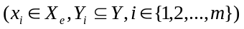, represents the real-valued function, and maps the outputs of f(x_{i}, y) for any to {1,2,...,|Y|} such that if f(x_{i}, y₁) > f(x_{i}, y₂) then rank_{f}(x_{i}, y₁) < rank_{f}(x_{i}, y₂), the specific definitions of the five evaluation indicators are as follows:
- Average precision: this reflects the average precision of predicted multiple labels by calculating the probability that a label ranking in front of the true label belongs to the true label sets. The larger the average precision, the better the performance.
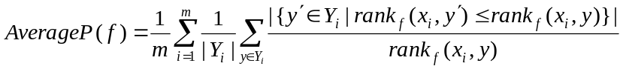 | (10)
- Coverage: this measures the average number of labels that need to be crossed from the label with the highest membership degree to cover all labels of the true label sets in the sorting queue, which is similar to the recall rate in the single-label classification. The smaller the value, the better the performance.
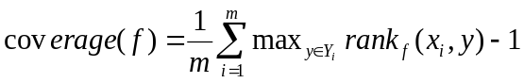 | (11)
- Hamming loss: the number of times the actual label does not appear in the predicted label set, that is, measurement of misclassification of a single label. The smaller the value, the better the performance. hloss(h)>=0.
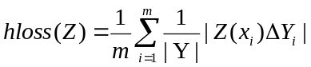 | (12)
where Z(x) denotes predicted label set as described in Equation 1 and 2, and Δ stands for the symmetric difference between two sets.
- One-error: this describes the possibility that the label with the highest membership degree in the prediction results is not the real label, which is the classification error rate in single-label learning. The smaller the value, the better the performance.
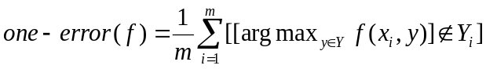 | (13)
- Ranking loss: this indicates the probability that the membership degree of a sample belonging to the true label set is lower than the probability that it does not belong to the true label set. The smaller the value, the better the performance.
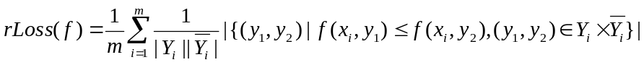 | (14)
The comparison algorithms used in this experiment include ML-KNN, BPMLL, MMP, and ADTBOOST.MH (multi-label decision tree). BRSVM, CCSVM, LPSVM, LPNB, BRNB. BRSVM, CCSVM and LPSVM are problem transformation methods by BR, CC and LP, and the basic classifier LibSVM is adopted. The kernel parameter gamma and the penalty C, for each combination of dataset and method, were determined by 5-fold cross validation using the training sets only. BRNB and LPNB are problem transformation methods by BR and LP, and naïve Bayes is the basic classifier. The parameters of ML-KNN, BRKNN, BPMLL and MMP trained are: for ML-KNN, the number of nearest neighbors considered is set to 10 and Euclidean distance is used as the distance measure; for BPMLL, the learning rate is set to be 0.05, the number of hidden neurons is set to 20% of the dimensionality and the number of training epochs is set to 100; for temporary perceptron in MMP, PERCEP_BIAS = 1, epochs = 1; for Adtboost.MH, the number of boosting rounds is set to be 50. The experimental comparison results measured by the above five evaluation indexes are reported in Table 3.
Table 3. Experimental performance results of each multi-label classification algorithm
Evaluation index | Algorithm
Evaluation index | ML-  KNN | BR  SVM | CC  SVM | LP  SVM | BRNB | LPNB | MMP | BPMLL | LPBayes Net | Adtboost.MH
Average Precision | 0.7295  ±0.0098 | 0.4758  ±0.0046 | 0.4758  ±0.0046 | 0.3008  ±0.0158 | 0.7078  ±0.0096 | 0.3021  ±0.0149 | 0.6279  ±0.0105 | 0.4461  ±0.0203 | 0.3049  ±0.0134 | 0.5052  ±0.0040
Hamming loss | 0.0232  ±0.0003 | 0.0231  ±0.0003 | 0.0231  ±0.0003 | 0.0273  ±0.0006 | 0.0238  ±0.0003 | 0.0273  ±0.0005 | - | 0.1654  ±0.0165 | 0.0272  ±0.0004 | 0.0304  ±0.0003
Coverage | 48.4716±1.8498 | 192.1619±4.4424 | 192.1619±4.4424 | 213.1907±1.9514 | 106.1280±5.1942 | 213.1900±1.9519 | 67.2345±3.3397 | 59.1679±0.9483 | 213.1439±1.9011 | 196.8563±2.5376
One Error | 0.0965  ±0.0170 | 0.3677  ±0.0113 | 0.3677  ±0.0113 | 0.1793  ±0.0935 | 0.1118  ±0.0121 | 0.1751  ±0.0878 | 0.1783  ±0.0111 | 0.9587  ±0.0358 | 0.1713  ±0.0691 | 0.1074  ±0.0122
Ranking Loss | 0.0341  ±0.0019 | 0.2484  ±0.0060 | 0.2484  ±0.0060 | 0.4163  ±0.0115 | 0.0760  ±0.0057 | 0.4161  ±0.0109 | 0.0590  ±0.0036 | 0.0724  ±0.0052 | 0.4153  ±0.0094 | 0.2852  ±0.0064

Our experimental results reveal that ML-KNN performs fairly well according to all of the evaluation indexes. In particular, ML-KNN outperforms all the other algorithms in terms of average precision, coverage, one-error and ranking loss. The reason may be that ML-KNN considers more medical knowledge such as correlation among symptoms when calculating similarity to neighbors by Euclidean distance than other methods that only consider correlation between symptoms and diagnostic tests. The results confirm that making use of neighborhood properties of the dataset is quite important in determining the appropriateness for diagnostic tests. Since the amount of data in this experiment is not large enough, the improvement on the performance of BPMLL and MMP based on neural network is lower than the improvement based on KNN. It is also worth noting that BRNB is the second best performing method, just following ML-KNN with respect to average precision. Moreover, performances on the other evaluation indexes are relatively higher than the majority of algorithms. However, LPNB, a data-transformed algorithm considering correlation within labels on the basis of the same classifier naïve Bayes, has poor performance as evaluated by average precision, coverage and ranking loss. This is also the case for BRSVM and LPSVM. Meanwhile, CCSVM receives the same evaluation as BRSVM, which means that considering correlation among labels by transiting label information in a chain will not make a difference. For this we have a hypothesis: in current studies, correlation among labels is assumed to be positive correlation by default. Positive correlation indicates that the presence of a certain label may lift the possibility of the other labels. However, in terms of the current data set where the diagnostic test is the representation of labels, it seems as if there is essentially no positive correlation among diagnostic tests. In contrast, the correlation among diagnostic tests is a negative correlation with mutually exclusive properties from a medical point of view. Indeed, it reflects the situation where the choice of one diagnostic test could make it unlikely that the diagnostic tests with same function will be recommended at same time. In the future, solving the problem on how to measure negative correlation with mutually-exclusive properties among diagnostic tests may improve the performance of decision-making.

5.3 Interpretability
To judge whether the diagnostic test given by doctors is inappropriate by CDFO-MIEC is a challenge to the authority of doctors. In order to improve trustworthiness, effectiveness, persuasiveness, and satisfaction, it is inevitably necessary etto give sufficient explains for the decision result from our decision approach. In this paper, we explain why a diagnostic test is determined as inappropriate by a decision feature of the path in CART. Each diagnostic test recommended by a physician is determined as inappropriate by CDFO-MIEC, an explanation will also be provided to support this determination. For example, a patient with a series of complaint symptoms such as ‘shortness of breath’, ‘chest distress’, ‘expectoration’, ‘sputum blockage and suffocation’, ‘cough’ may be given a primary disease diagnosis of ‘chronic obstructive pulmonary disease with acute exacerbation’, and a differential disease will be ‘obsolete pulmonary tuberculosis’. In such a case the ‘colonoscopy’ judged by our model would be regarded as inappropriate. CART makes the decision using Evaluation strategy 1 and Evaluation strategy 2 which are the correlation between complaint symptoms and diagnostic tests and usage rate under the condition of related disease. Therefore, we provide the explains that ‘colonoscopy’ has a lower correlation with symptoms, ranking 151st of 230, and that the usage rate under the condition of primary disease and differential disease is low with a ranking of 215th out of 230. In view of these results, this evidence proves that it is inappropriate to select this diagnostic test for this patient.

6 Conclusions and future work
In this paper, we proposed CDFO-MIEC, a uniform model-based framework to automatically determine whether the diagnostic tests recommended by a physician are appropriate for a patient. This framework overcame the diversity limitations of the existing CPG-based decision-making methods by modeling the implicit evaluation criteria summarized from subjective medical decision-making process, which formed a unified standard to determine the appropriateness of diagnostic tests for different diseases. To the implicit evaluation criteria including the correlation with symptoms and diseases, exclusion function and confirmation function, we provided four evaluation strategies implemented by statistic-based methods for making decisions objectively. To improve the trustworthiness, effectiveness, and persuasiveness of CDFO-MIEC, we presented evidences for the decision that the selected diagnostic test was inappropriate using the decision conditions in CART. Empirical tests with actual records illustrated that CDFO-MIEC is feasible with a reliable high performance on Macro_F₁ of 0.9167. To the best of our knowledge, this is a unique automatic decision-making framework against over-testing with uniform evaluation criteria. Its good performance provides a solution for determining the appropriateness of diagnostic tests objectively and it may further lead to innovations against over-testing with automatic methods.
Acknowledge
This work is supported by National Natural Science Foundation of China (Grant No. 71531007 and No. 71471048). We would like to thank the cooperation hospital for providing the EMRs. We thank International Science Editing ( http://www.internationalscienceediting.com ) for editing this manuscript. We also want to thank the anonymous reviewers for their comments, which provided us with significant guidance.

References
[1] H. G. Welch and W. C. Black.Overdiagnosis in cancer[J]. Journal of the National Cancer Institute, vol. 102, pp. 605-613, 2010.
[2] S. Brownlee, K. Chalkidou, J. Doust, A. G. Elshaug, P. Glasziou, I. Heath, et al.Evidence for overuse of medical services around the world[J]. The Lancet, vol. 390, pp. 156-168, 2017.
[3] J. M. McGinnis, L. Stuckhardt, R. Saunders, and M. Smith, Best care at lower cost: the path to continuously learning health care in America: National Academies Press, 2013.
[4] B. Hofmann and H. G. Welch.New diagnostic tests: more harm than good[J]. Bmj, vol. 358, p. j3314, 2017.
[5] P. L. Epner, J. E. Gans, and M. L. Graber.When diagnostic testing leads to harm: a new outcomes-based approach for laboratory medicine[J]. BMJ Qual Saf, vol. 22, pp. ii6-ii10, 2013.
[6] S. Miyakis, G. Karamanof, M. Liontos, and T. D. Mountokalakis.Factors contributing to inappropriate ordering of tests in an academic medical department and the effect of an educational feedback strategy[J]. Postgraduate medical journal, vol. 82, pp. 823-829, 2006.
[7] P. H. R. Institute.Identifying Waste in Healthcare Spending[J]. PricewaterhouseCoopers, 2010.
[8] D. E. Leaf, A. Srivastava, X. Zeng, G. M. McMahon, H. E. Croy, M. L. Mendu, et al.Excessive diagnostic testing in acute kidney injury[J]. BMC nephrology, vol. 17, p. 9, 2016.
[9] G. R. Kruse, S. M. Khan, A. M. Zaslavsky, J. Z. Ayanian, and T. D. Sequist.Overuse of colonoscopy for colorectal cancer screening and surveillance[J]. Journal of general internal medicine, vol. 30, pp. 277-283, 2015.
[10] G. Draisma, R. Etzioni, A. Tsodikov, A. Mariotto, E. Wever, R. Gulati, et al.Lead time and overdiagnosis in prostate-specific antigen screening: importance of methods and context[J]. Journal of the National Cancer Institute, vol. 101, pp. 374-383, 2009.
[11] C. R. Carpenter, A. S. Raja, and M. D. Brown.Overtesting and the Downstream Consequences of Overtreatment: Implications of “Preventing Overdiagnosis” for Emergency Medicine[J]. Academic Emergency Medicine Official Journal of the Society for Academic Emergency Medicine, vol. 22, pp. 1484-1492, 2015.
[12] S. Belicky and J. Tkac, "Glycoprofiling: A key to early prostate cancer diagnostics," in 2015 9th International Conference on Sensing Technology (ICST), 2015, pp. 520-524.
[13] A. L. Fisher.The Dilemma of Overtreatment[J]. Journal of American Physicians and Surgeons, vol. 23, pp. 36-38, 2018.
[14] R. G. Mccoy, H. K. V. Houten, J. S. Ross, V. M. Montori, and N. D. Shah.HbA1c overtesting and overtreatment among US adults with controlled type 2 diabetes, 2001-13: observational population based study[J]. Bmj British Medical Journal, vol. 351, p. h6138, 2015.
[15] H. K. Kanzaria, J. R. Hoffman, M. A. Probst, J. P. Caloyeras, S. H. Berry, and R. H. Brook.Emergency physician perceptions of medically unnecessary advanced diagnostic imaging[J]. Academic Emergency Medicine, vol. 22, pp. 390-398, 2015.
[16] M. Soshi, T. Mizuta, and Y. Tokuda, "Overtesting in Japan," ed: Wiley-Blackwell, 2018.
[17] H. Lyu, T. Xu, D. Brotman, B. Mayer-Blackwell, M. Cooper, M. Daniel, et al.Overtreatment in the United States[J]. PLoS One, vol. 12, p. e0181970, 2017.
[18] J. R. Hoffman and C. R. Carpenter.Guarding against overtesting, overdiagnosis, and overtreatment of older adults: thinking beyond imaging and injuries to weigh harms and benefits[J]. 2017.
[19] E. B. Tapper, N. Sengupta, M. Lai, and G. Horowitz.A Decision Support Tool to Reduce Overtesting for Ceruloplasmin and Improve Adherence With Clinical Guidelines[J]. Jama Internal Medicine, vol. 175, 2015.
[20] M. Zhi, E. L. Ding, J. Theisen-Toupal, J. Whelan, and R. Arnaout.The landscape of inappropriate laboratory testing: a 15-year meta-analysis[J]. PloS one, vol. 8, p. e78962, 2013.
[21] M. T. Lu, D. A. Rosman, C. C. Wu, M. D. Gilman, H. B. Harvey, D. A. Gervais, et al.Radiologist Point-of-Care Clinical Decision Support and Adherence to Guidelines for Incidental Lung Nodules[J]. Journal of the American College of Radiology, vol. 13, pp. 156-162, 2016.
[22] E. Choi, M. T. Bahadori, A. Schuetz, W. F. Stewart, and J. Sun, "Doctor AI: Predicting Clinical Events via Recurrent Neural Networks," 2016.
[23] J. Shang, C. Xiao, T. Ma, H. Li, and J. Sun.GAMENet: Graph Augmented MEmory Networks for Recommending Medication Combination[J]. arXiv preprint arXiv:1809.01852, 2018.
[24] J. Wyatt and D. Spiegelhalter, "Field trials of medical decision-aids: potential problems and solutions," in Proceedings of the annual symposium on computer application in medical care, 1991, p. 3.
[25] S. Lancini, M. Lazzari, A. Masera, and P. Salvaneschi.Diagnosing ancient monuments with expert software[J]. Structural engineering international, vol. 7, pp. 288-291, 1997.
[26] S. Rahaman, "Diabetes diagnosis decision support system based on symptoms, signs and risk factor using special computational algorithm by rule base," in 2012 15th International Conference on Computer and Information Technology (ICCIT), 2012, pp. 65-71.
[27] R.-C. Chen and C.-T. Bau.An ontological approach for guideline-based decision support system[J]. International Journal of Computer, Consumer and Control (IJ3C), vol. 2, pp. 27-34, 2013.
[28] F. De Backere, H. Moens, K. Steurbaut, K. Colpaert, J. Decruyenaere, and F. De Turck.Towards automated generation and execution of clinical guidelines: Engine design and implementation through the ICU Modified Schofield use case[J]. Computers in biology and medicine, vol. 42, pp. 793-805, 2012.
[29] Z. Yang, Y. Huang, Y. Jiang, Y. Sun, Y.-J. Zhang, and P. Luo.Clinical assistant diagnosis for electronic medical record based on convolutional neural network[J]. Scientific reports, vol. 8, p. 6329, 2018.
[30] U. Adil, M. Jussi, L. Hilkka, K. Juha, L. Jyrki, K. Ari, et al.A Decision Support System for Diagnostics and Treatment Planning in Traumatic Brain Injury[J]. IEEE Journal of Biomedical and Health Informatics, pp. 1-1.
[31] J. Jiang, X. Li, C. Zhao, Y. Guan, and Q. Yu.Learning and inference in knowledge-based probabilistic model for medical diagnosis[J]. Knowledge-Based Systems, vol. 138, pp. 58-68, 2017.
[32] Z. C. Lipton, D. C. Kale, C. Elkan, and R. Wetzel.Learning to diagnose with LSTM recurrent neural networks[J]. arXiv preprint arXiv:1511.03677, 2015.
[33] J. Mullenbach, S. Wiegreffe, J. Duke, J. Sun, and J. Eisenstein.Explainable Prediction of Medical Codes from Clinical Text[J]. 2018.
[34] Y. Coppieters and A. Levêque.Ethics, privacy and the legal framework governing medical data: opportunities or threats for biomedical and public health research?[J]. Archives of public health, vol. 71, p. 15, 2013.
[35] B. M. Nguyen, K. W. Lin, and R. Mishori.Public health implications of overscreening for carotid artery stenosis, prediabetes, and thyroid cancer[J]. Public Health Reviews, vol. 39, p. 18, 2018.
[36] F. Eva, Q. Rosanna, C. Laura, C. Piero, and B. Silvio.Appropriate laboratory utilization in diagnosing pulmonary embolism[J]. Annals of clinical biochemistry, vol. 46, pp. 18-23, 2009.
[37] H. S. Ahn and H. J. Kim.Development and implementation of clinical practice guidelines: current status in Korea[J]. Journal of Korean medical science, vol. 27, pp. S55-S60, 2012.
[38] J. W. O’Sullivan, A. Albasri, B. D. Nicholson, R. Perera, J. K. Aronson, N. Roberts, et al.Overtesting and undertesting in primary care: a systematic review and meta-analysis[J]. BMJ open, vol. 8, p. e018557, 2018.
[39] R. Borgonjen, J. de Lange, and P. van de Kerkhof.GUIDELINE-BASED CLINICAL DECISION SUPPORT[J]. J Eur Acad Dermatol Venereol, vol. 31, pp. e440-e442, 2017.
[40] Y. Zhai, Z. Xu, and H. Liao.Measures of probabilistic interval-valued intuitionistic hesitant fuzzy sets and the application in reducing excessive medical examinations[J]. IEEE Transactions on Fuzzy Systems, vol. 26, pp. 1651-1670, 2018.
[41] Y. Wang, P. Li, Y. Tian, J.-j. Ren, and J.-s. Li.A Shared Decision Making System for Diabetes Medication Choice Utilizing Electronic Health Record Data[J]. IEEE Journal of Biomedical and Health Informatics, pp. 1-1.
[42] S. Bromuri, D. Zufferey, J. Hennebert, and M. Schumacher.Multi-label classification of chronically ill patients with bag of words and supervised dimensionality reduction algorithms[J]. Journal of biomedical informatics, vol. 51, pp. 165-175, 2014.
[43] M.-L. Zhang and Z.-H. Zhou.A review on multi-label learning algorithms[J]. IEEE transactions on knowledge and data engineering, vol. 26, pp. 1819-1837, 2014.
[44] X. Shen, M. Boutell, J. Luo, and C. Brown, "Multilabel machine learning and its application to semantic scene classification," in Storage and Retrieval Methods and Applications for Multimedia 2004, 2003, pp. 188-200.
[45] M.-L. Zhang and K. Zhang, "Multi-label learning by exploiting label dependency," in Proceedings of the 16th ACM SIGKDD international conference on Knowledge discovery and data mining, 2010, pp. 999-1008.
[46] J. Read, B. Pfahringer, G. Holmes, and E. Frank.Classifier chains for multi-label classification[J]. Machine learning, vol. 85, p. 333, 2011.
[47] M.-L. Zhang and Z.-H. Zhou.ML-KNN: A lazy learning approach to multi-label learning[J]. Pattern recognition, vol. 40, pp. 2038-2048, 2007.
[48] M.-L. Zhang and Z.-H. Zhou.Multilabel neural networks with applications to functional genomics and text categorization[J]. IEEE transactions on Knowledge and Data Engineering, vol. 18, pp. 1338-1351, 2006.
[49] K. Crammer and Y. Singer.A family of additive online algorithms for category ranking[J]. Journal of Machine Learning Research, vol. 3, pp. 1025-1058, 2003.
[50] L. A. Al-Gwaiz and H. H. Babay.The diagnostic value of absolute neutrophil count, band count and morphologic changes of neutrophils in predicting bacterial infections[J]. Medical Principles and Practice, vol. 16, pp. 344-347, 2007.
[51] M. A. Razi and K. Athappilly.A comparative predictive analysis of neural networks (NNs), nonlinear regression and classification and regression tree (CART) models[J]. Expert Systems with Applications, vol. 29, pp. 65-74, 2005.
[52] S. Pai and G. D. Bader.Patient similarity networks for precision medicine[J]. Journal of molecular biology, 2018.
[53] L. S. Feldman, H. M. Shihab, D. Thiemann, H.-C. Yeh, M. Ardolino, S. Mandell, et al.Impact of providing fee data on laboratory test ordering: a controlled clinical trial[J]. JAMA internal medicine, vol. 173, pp. 903-908, 2013.
[54] T. Kang, S. Zhang, N. Xu, D. Wen, X. Zhang, and J. Lei.Detecting negation and scope in Chinese clinical notes using character and word embedding[J]. Computer methods and programs in biomedicine, vol. 140, pp. 53-59, 2017.
[55] P. Nguyen, T. Tran, N. Wickramasinghe, and S. Venkatesh.Deepr: A Convolutional Net for Medical Records[J].
[56] J. Liang, X. Xian, X. He, M. Xu, S. Dai, J. y. Xin, et al.A novel approach towards medical entity recognition in Chinese clinical text[J]. Journal of healthcare engineering, vol. 2017, 2017.
[57] X. Dong, S. Chowdhury, L. Qian, G. Yi, J. Yang, and Q. Yu, "Transfer bi-directional LSTM RNN for named entity recognition in Chinese electronic medical records," in IEEE International Conference on E-health Networking, 2017.
[58] B. He, B. Dong, Y. Guan, J. Yang, Z. Jiang, Q. Yu, et al.Building a comprehensive syntactic and semantic corpus of Chinese clinical texts[J]. Journal of biomedical informatics, vol. 69, pp. 203-217, 2017.
[59] J. Lei, B. Tang, X. Lu, K. Gao, M. Jiang, and H. Xu.A comprehensive study of named entity recognition in Chinese clinical text[J]. Journal of the American Medical Informatics Association, vol. 21, pp. 808-814, 2013.
[60] B. Rink, S. Harabagiu, and K. Roberts.Automatic extraction of relations between medical concepts in clinical texts[J]. Journal of the American Medical Informatics Association, vol. 18, pp. 594-600, 2011.
[61] I2B2, Informatics for Integrating Biology & the Bedside[J].
[62] M. Gridach.Character-level neural network for biomedical named entity recognition[J]. Journal of biomedical informatics, vol. 70, pp. 85-91, 2017.
[63] X. C. Maosong Sun, Kaixu Zhang, Zhipeng Guo, Zhiyuan Liu.THULAC: An Efficient Lexical Analyzer for Chinese[J]. 2016.
[64] S. Li, Z. Zhao, R. Hu, W. Li, T. Liu, and X. Du.Analogical reasoning on chinese morphological and semantic relations[J]. arXiv preprint arXiv:1805.06504, 2018.
[65] H. Zhu, R. Xie, Z. Liu, and M. Sun, "Iterative Entity Alignment via Joint Knowledge Embeddings," in IJCAI, 2017, pp. 4258-4264.
[66] V. I. Levenshtein, "Binary codes capable of correcting deletions, insertions, and reversals," in Soviet physics doklady, 1966, pp. 707-710.
[67] R. Foorthuis, "The Impact of Discretization Method on the Detection of Six Types of Anomalies in Datasets," in Proceedings of the 30th Benelux Conference on Artificial Intelligence (BNAIC 2018), 2018.
[68] G. Madjarov, D. Kocev, D. Gjorgjevikj, and S. Džeroski.An extensive experimental comparison of methods for multi-label learning[J]. Pattern recognition, vol. 45, pp. 3084-3104, 2012.
[69] Y. Zhang and X. Chen.Explainable recommendation: A survey and new perspectives[J]. arXiv preprint arXiv:1804.11192, 2018.

